

COURSE PROJECT SPRING 2024

Course Title: Fundamentals of Software Project Management
Course Instructor: Ubaid Aftab Chawla

CONTENT

Project Plan 2024 4
Business Statement 6
Organization Background 6
Opportunity Or Problem 6
Project Team 7
Resource Allocation 7
Project Team Structure 10
Feasibility Analysis 12
Feasibility Analysis 12
Critical Success Factors of the Project 14
Project Aims and Goals 15
Aim of the Project 15
Goals of the Project 15
Benefits to the organization 15
Project Deliverable 16
4. Training Programs and Materials 17
5. Security Audit Reports 18
6. Deployment and Maintenance Plan 18
7. Compliance Documentation 18
8. Public Communication Strategy 19
Summary 19
Project Scope 19
Boundaries of the Project 19
Inclusions and Exclusions 20
Inclusions 20
Exclusions 21
Project Phases and Parts 21
Success criteria 23
Software Process Model Implemented 23
Agile User Stories 24
User Study 24
1. Voters 24
2. Election Officials 24
3. System Administrators 25
Assumptions, Constraints, and Dependencies 26
Assumptions 26
Constraints 26
External Dependencies 27
Stakeholders 27
Identification of Stakeholders 27
Roles of Stakeholders 27
Deliverable & Signing Authorities 29
Expert 30
Expert Details 30
Name: Abeeha Sattar 30
Past Experiences & Success 30
➢ Developer (EasyPaisa Website) / Course Instructor 30
➢ Role in the Project Developer (frontend (to some extent) /backend) 30
Work Breakdown Structure 30
WBS of the Project 30
Expert Approval 43
MS Project Plan Overview 43
Overview 43
Expert Approval 43
Snapshots of Essential Components of Project Plan 43
Time Phased Budget 51
Time Phased Budget Analysis 51
Summary 52

Project Plan 2024
Start Date: 00/00/2024
End Date: 00/00/2024

PROJECT TITLE
Block-Chain Based VOTING System

PROJECT CONTRIBUTORS
ABDULLAH JAWAD
FIZZA RASHID
TALHA PERVAIZ

SUBMITTED TO
SIR UBAID AFTAB

Business Statement

Organization Background
XYZ Company is a leading technology solutions provider specializing in blockchain applications. With a proven track record of delivering innovative, secure, and scalable solutions, XYZ Company has been entrusted by the Government of Pakistan with the development of a state-of-the-art blockchain-based voting system. This initiative is in partnership with the National Database and Registration Authority (NADRA) and the Election Commission of Pakistan, leveraging their comprehensive voter data to ensure the inclusivity and accuracy of the electoral process.

Opportunity Or Problem
Statement:
Despite continuous efforts to enhance the electoral process, issues such as vote tampering, low voter turnout due to accessibility issues, and concerns over the confidentiality of votes persist. These issues undermine public trust in the electoral process and can impact the democratic outcomes. The COVID-19 pandemic has further emphasized the need for a robust remote voting solution that can ensure the safety of voters while maintaining the integrity of the electoral process.
Proposed Solution:
In response to these challenges, XYZ Company proposes to develop a blockchain-based voting system, utilizing voter data provided by NADRA and overseen by the Election Commission of Pakistan. This innovative system will use blockchain technology to ensure that each vote is securely encrypted and immutably recorded on a decentralized ledger. This approach guarantees the integrity of every vote, eliminates the risk of tampering, and ensures the transparency of the voting process.

Project Team

Resource Allocation
- Project Manager | Numbers Required: 1 | Why Needed? To oversee the entire project, manage timelines, budgets, and risks, and ensure project objectives are met. The project manager will serve as the primary point of communication between stakeholders and the technical team.
- Blockchain developers | Numbers Required:3-4 | Why Needed? To design and implement the blockchain infrastructure, develop and test smart contracts, and integrate blockchain with other system components. Their expertise in Solidity and blockchain architectures is crucial for the core functionality of the voting system.
- Front-end developers | Numbers Required: 2-3 | Why Needed? To create a user-friendly interface for voters and administrators. They are responsible for implementing responsive web design and ensuring accessibility standards are met, using HTML, CSS, JavaScript, and libraries such as React or Angular.
- Back-end developers | Numbers Required: 2-3 | Why Needed? To develop the server-side logic, APIs, and integrate with the blockchain and external databases (e.g., NADRA’s API for voter verification). They ensure that the backend infrastructure supports the functionalities of the frontend and interacts seamlessly with the blockchain.
- Security Analyst | Numbers Required: 2 | Why Needed? To safeguard the system against security threats and ensure data integrity and voter privacy. Their role involves conducting security audits, vulnerability assessments, and implementing security protocols, crucial for the credibility of the voting system.
- QA/Test Engineers | Numbers Required: 2-3 | Why Needed? To manage the quality assurance process, including drafting test cases, conducting various tests (unit, integration, user acceptance), and ensuring the final product is bug-free and meets all specifications.
- UI/UX designers | Numbers Required: 1-2 | Why Needed? To design intuitive and accessible user interfaces, conduct usability tests, and ensure a positive user experience, critical for user engagement and system adoption.
- DevOps Engineers | Numbers Required: 1 | Why Needed? To manage operations and development, oversee continuous integration and continuous deployment (CI/CD) pipelines, and maintain server and network infrastructure to ensure high availability and scalability of the voting system.
- Legal & Compliance Expert | Numbers Required: 1 | Why Needed? To ensure the system complies with all relevant laws and regulations, which is essential for legal operation and to maintain public trust.
- Training & Documentation Specialists | Numbers Required: 1 | Why Needed? To develop comprehensive user manuals and training materials and conduct training sessions for end-users and administrators, ensuring smooth adoption and operation of the system.

Project Team Structure
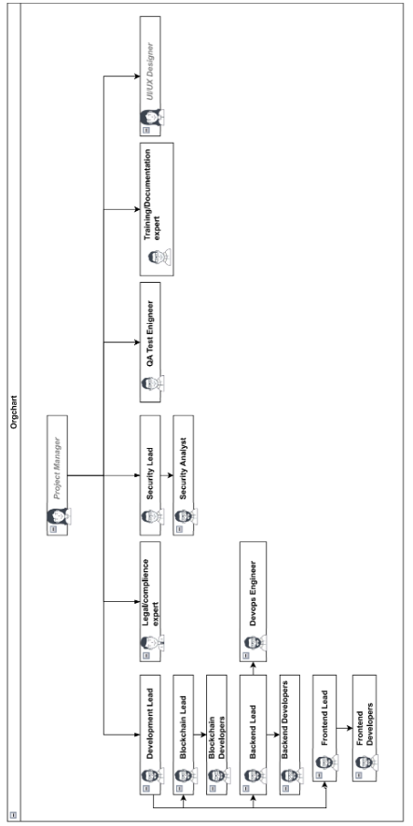
Description:
This structure supports streamlined communication and efficient management of resources. Each team has clearly defined roles that contribute to the system's functionality, security, and usability. The layered structure ensures that technical details are handled by experts in each domain, while overarching coordination and strategic decisions are managed by the project manager.
This setup optimizes resource utilization and ensures all critical areas of the project are covered, from technical development to compliance and user training.

Feasibility Analysis

Feasibility Analysis

- Technical Feasibility | Rating: 8/10  Justification:The technical feasibility is high as blockchain technology is well-established and proven in similar applications, like secure transactions and data integrity maintenance. However, the complexity lies in integrating blockchain with existing voter databases and ensuring system scalability and performance under high load, which can be technically challenging.  CSF:Robust blockchain infrastructure,seamless integration with NADRA’s API.  Measures taken: Employing experienced blockchain developers and using proven blockchain frameworks like Ethereum. Rigorous testing environments are set up to simulate election conditions.
- Economic Feasibility | Rating: 7/10  Justification:The initial costs for developing a blockchain-based system are significant, due to the need for specialized skills and high-end security measures. However, the long-term benefits such as reduced fraud, lower operational costs during elections, and enhanced trust in the electoral process justify the investment.  CSF:Adequate funding allocation, return on investment through operational savings.  Measures taken: Developing a detailed budget and securing funding based on a clear ROI analysis that demonstrates potential cost savings and efficiency gains in electoral processes.
- OperationalFeasibility | Rating: 6/10  Justification:The success of the voting system depends on its acceptance by end-users, which includes election officials and voters. Challenges in user adoption due to technology resistance or lack of digital literacy can impact operational feasibility.  CSF:User-friendly interface, effective training programs.  Measures taken: Conducting workshops and training sessions for election officials and voters. Designing an intuitive user interface with the help of expert UI/UX designers.
- Legal Feasibility | Rating: 5/10  Justification:The voting system must comply with national election laws and data protection regulations, which can vary and change over time. Navigating this regulatory landscape can be complex and poses a significant risk if not managed properly.  CSF: Compliance with electoral laws and data protection regulations.  Measures taken: Consulting with legal experts specializing in electoral law and technology to ensure all aspects of the system are legally compliant. Regularly updating the compliance measures based on changes in the law.

Critical Success Factors of the Project
- The foundation of the system relies on secure, scalable, and reliable blockchain technology, capable of handling high transaction volumes and safeguarding data integrity.
- For the system to function effectively, it must integrate flawlessly with the National Database and Registration Authority's API for real-time voter authentication and verification.
- The project's success depends on the skills and expertise of the development team, particularly their proficiency in blockchain technologies and smart contract development.
- Implementing established blockchain frameworks like Ethereum ensures that the system is built on secure and tested foundations.
- Establishing comprehensive testing environments that can simulate election conditions is crucial to ensure the system's reliability under real-world stress scenarios.
- Ensuring that the system adheres to all applicable laws, regulations, and standards is paramount for legal operation and to maintain public trust.
- Active engagement and cooperation among all stakeholders, including government bodies, election officials, and voters, are essential for smooth implementation and widespread adoption.
- The system must be transparent and trusted by the public to encourage adoption and participation, which is key to the modernization of the voting process.
- Providing comprehensive training to election officials and technical support teams will facilitate the successful operation of the system during elections.
- The system should be designed with scalability in mind, capable of adapting to increasing voter numbers and incorporating future technological advancements.

Project Aims and Goals

Aim of the Project
The primary aim of the project is to develop and implement a secure, transparent, and accessible blockchain-based voting system that enhances the integrity and efficiency of the electoral process in Pakistan.

Goals of the Project
- By leveraging blockchain technology, the project aims to minimize electoral fraud and ensure that each vote is recorded accurately and immutably.
- The system will provide remote voting capabilities, reducing physical barriers to voting and enabling a broader demographic to participate in elections, including those unable to visit polling stations.
- Automating the voting process will streamline operations, significantly reduce the time and resources required for vote counting and results compilation, and lower the overall cost of conducting elections.
- By making the voting process more transparent and secure, the system is expected to increase public confidence in the electoral outcomes.

Benefits to the organization
- Successfully deploying a technologically advanced voting solution will position the Government of Pakistan and its collaborating organizations as leaders in adopting innovative technologies for public welfare.
- The blockchain system will automate many aspects of the electoral process, reducing the dependency on manual tasks and the potential for human error, thus optimizing operational efficiencies.
- Blockchain's inherent characteristics of decentralization, immutability, and encryption will significantly enhance the security and integrity of voter data and voting results.
- The system is designed to be scalable, allowing for future enhancements such as integration with other e-government services. This scalability ensures that the system can adapt to increasing voter numbers and changing technologies without substantial overhauls.
- By facilitating a more inclusive and accessible voting process, the system strengthens the democratic process, ensuring that more citizens can exercise their right to vote without prejudice or hindrance.

Project Deliverable
Deliverable
- Blockchain-based Voting System Software | Objective Linkage: Implements the core technology for secure and transparent voting processes. | Success Criteria: System passes all security audits, demonstrates robustness during testing phases, and aligns with all functional and nonfunctional requirements.
- Voter Authentication System | Objective Linkage: Ensures that only eligible voters can access the voting system, linking directly to the integrity and security of the electoral process. | Success Criteria: The authentication system integrates seamlessly with NADRA's API, achieves an error rate below 0.1%, and handles peak loads efficiently.
- User Interface (UI) for Voters and Administrators | Objective Linkage: Provides user-friendly access to the voting system for voters and efficient management capabilities for administrators, aiming to boost voter turnout and operational efficiency. | Success Criteria: UI is accessible and complies with web accessibility guidelines (WCAG), receives positive feedback (>80% satisfaction) from user acceptance testing, and includes multilingual support.
Training Programs and Materials | Objective Linkage: Ensures election officials and technical support teams are well-prepared to manage and operate the voting system, directly supporting operational efficiency and system usability. | Success Criteria: All designated personnel complete training with a minimum proficiency score of 90%, and post-training evaluations indicate a high level of confidence in using the system.
Security Audit Reports | Objective Linkage: Validates the security measures implemented within the voting system, contributing directly to the goal of enhanced electoral integrity. | Success Criteria: The system meets or exceeds all national and international standards for data security and privacy, with no critical vulnerabilities reported.
Deployment and Maintenance Plan | Objective Linkage: Outlines the systematic approach for deploying and maintaining the system, ensuring its long-term viability and performance, which supports the scalability and reliability goals. | Success Criteria: Deployment follows the planned schedule within the budget, and the maintenance plan demonstrates effective handling of anticipated issues during operation.
Compliance Documentation | Objective Linkage: Ensures the system adheres to all relevant legal and regulatory requirements, crucial for legal operation and to maintain public trust | Success Criteria: The system receives all necessary certifications and approvals before deployment, and documentation supports compliance claims during audits.
Public Communication Strategy | Objective Linkage: Designed to inform and educate the public about the new voting system, aiming to increase voter engagement and trust. | Success Criteria: Achieves a measurable increase in public awareness and positive public perception as tracked through surveys and feedback mechanisms.

Summary
Each deliverable is intricately linked to one or more specific objectives of the project, ensuring a strategic approach to project management and execution. Success criteria are set to measure the effectiveness and efficiency of each deliverable, ensuring that they meet the intended goals and contribute positively to the overall success of the project.

Project Scope

Boundaries of the Project
- The project encompasses the development and implementation of Block-chain Based voting system.
- The project includes following stages/phases of SDLC: design, development, testing, deployment.

- Project scope is limited to the technical aspects of the Voting management system and does not include political or regulatory considerations.

Inclusions and Exclusions

Inclusions
- System Development:
  - Design and implementation of a blockchain infrastructure to support the voting process.
  - Development of a secure voter authentication mechanism using data provided by NADRA.
  - User interface design that is accessible to a broad demographic, including persons with disabilities.
  - Implementation of encryption and other security measures to protect voter privacy and vote integrity.
- Testing and Quality Assurance:
  - Comprehensive testing phases including unit testing, integration testing, and user acceptance testing (UAT).
  - Security auditing by independent third parties to identify and mitigate potential vulnerabilities.
- Training and Documentation:
  - Preparation of detailed documentation for system administrators and end-users.
  - Training sessions for Election Commission officials and technical staff on managing and operating the voting system.
- Deployment and Support:
  - Roll-out of the voting system in phases, as determined by the Election Commission of Pakistan.
  - Ongoing technical support and system maintenance post-deployment.
- Legal and Regulatory Compliance:
  - Ensuring all aspects of the voting system adhere to Pakistani law and electoral regulations.
  - Collaboration with legal experts to address any regulatory concerns related to blockchain technology and digital voting.

Exclusions
- The project will not cover the creation or management of the physical infrastructure (e.g., servers, data centers) which will be the responsibility of the Government of Pakistan or its designated agencies.
- Voter education and awareness campaigns are considered outside the scope of this project and should be handled by the Election Commission of Pakistan.
- The system will not alter or replace the existing voter registration process managed by NADRA.

Project Phases and Parts

Requirements Gathering:
Identify stakeholders' requirements for the blockchain-based voting system.
Determine functional and non-functional requirements such as security, scalability, and usability.
Conduct workshops, interviews, and surveys to gather comprehensive requirements.
Requirement Analysis:
Analyze the gathered requirements to understand the scope and feasibility of the project.
Identify potential risks and constraints associated with the development and deployment of the system.
Define system architecture and design considerations, including the choice of blockchain platform and consensus mechanism.
Design:
Design the architecture of the blockchain-based voting system, including the blockchain network topology.
Define the data model for storing voting records securely on the blockchain.
Design user interfaces for voters to cast their votes and for administrators to manage the voting process.
Specify cryptographic protocols and mechanisms for ensuring the integrity and security of the voting system.
Implementation:
Develop smart contracts to handle voting logic and execution on the blockchain.
Implement the backend infrastructure for connecting the frontend interfaces with the blockchain network.
Develop frontend applications for voters and administrators, ensuring usability and accessibility.
Integrate cryptographic libraries and protocols for secure communication and data storage.
Testing:
Conduct unit testing to ensure the functionality of individual components such as smart contracts and user interfaces.
Perform integration testing to verify the interaction between different system modules.
Conduct security testing to identify and mitigate vulnerabilities such as double voting or tampering with voting records.
Test the system's scalability by simulating a large number of concurrent voters.
Deployment:
Deploy the blockchain-based voting system on a suitable blockchain platform, such as Ethereum or Hyperledger.
Configure network settings and permissions to ensure the integrity and security of the deployed system.
Conduct user acceptance testing (UAT) to validate that the deployed system meets stakeholders' requirements.
Monitor the system during the initial voting periods to address any issues or performance concerns.
Maintenance:
Provide ongoing maintenance and support for the deployed voting system.
Address any bugs, performance issues, or security vulnerabilities that arise during operation.
Update the system as needed to incorporate new features or enhancements based on user feedback and changing requirements.
Ensure compliance with relevant regulations and standards governing voting systems.

Success criteria
- The system must be available during Peak Voting Periods with minimal downtime, promoting system reliability.
- Votes are securely recorded and cannot be easily tampered with.
- The system's User Interface is intuitive as well as accessible to all eligible voters.
- The system should handle a large number of Voters without degradation of performance.
- The system should adhere to relevant data protection and privacy regulations.

Software Process Model Implemented
Process Model: Agile

The project will follow an agile approach to allow for iterative development and flexibility in responding to changes in requirements or technology. This will involve frequent communication with stakeholders, incremental development cycles, and continuous integration and testing.

Agile User Stories

User Study

Voters
- As a voter, I want to be able to register to vote online so that I can participate in elections without needing to visit a registration center.
Acceptance Criteria: Voters can create a profile using their national ID number, the system verifies voter eligibility through NADRA's API and voters receive confirmation of their registration status.
- As a voter, I want to log into the secure voting portal so that I can cast my vote confidentially and securely Acceptance Criteria:Login requires two-factor authentication and the system logs each login attempt for security monitoring.
- As a voter, I want to select candidates from a digital ballot so that I can easily make my choices known in a user-friendly interface. Acceptance Criteria: The ballot interface is clear and accessible on both desktop and mobile devices, voters can change their selection before final submission and voters receive a confirmation screen before their vote is cast.
- As a voter, I want to receive a confirmation receipt after voting so that I can be sure my vote has been recorded accurately. Acceptance Criteria:After voting, the system generates a digital receipt that includes a non-specific, secure confirmation code and voters can save or print the receipt for their records.

Election Officials
- As an election official, I want to monitor real-time voting data so that I can ensure the voting process is running smoothly. Acceptance Criteria:Officials have access to a dashboard that displays real-time data on voter turnout and system performance and the system alerts officials to any potential issues or irregularities.
- As an election official, I want to be able to close the voting and start the counting process so that results can be processed promptly after the election closes. Acceptance Criteria:Officials can initiate vote counting with a secure command that verifies their authorization and the system logs all actions taken by officials.

System Administrators
- As a system administrator, I want to manage user accounts and permissions so that I can ensure only authorized personnel have access to sensitive functions. Acceptance Criteria:Administrators can add, remove, or modify user roles and permissions through a management dashboard and changes to permissions are logged and can be audited.
- As a system administrator, I want to be able to deploy updates and patches securely so that the system remains secure and functional without interrupting ongoing operations. Acceptance Criteria: Administrators can schedule updates during low-traffic periods and the system provides rollback options in case of failed updates.

Assumptions, Constraints, and Dependencies

Assumptions
- It is assumed that the majority of voters have access to internet-enabled devices to participate in online voting.
- Voters and election officials are assumed to have basic digital literacy skills necessary to use the system effectively.
- The system assumes reliable and continuous internet connectivity during election periods to support system functionality.
- It is assumed that existing security measures and protocols are sufficient to protect the system against common cybersecurity threats.
- The project assumes that all necessary regulatory and legal approvals for the use of blockchain technology in elections will be obtained before deployment.

Constraints
- The project must be completed within a 12-month period to be ready for deployment in the next scheduled elections.
- The budget is fixed and any cost overruns must be approved by additional funding rounds, which could delay the project.
- Skilled blockchain developers and security experts are in high demand and may be difficult to recruit promptly.
- The complexity of integrating blockchain technology with existing voter databases may limit the system’s functionality or scalability.
- Resistance to change within the electorate or from political entities could impact the adoption and rollout of the system.

External Dependencies
- The system’s performance is heavily dependent on external APIs, particularly the integration with NADRA for real-time voter verification.
- Any changes in national election laws or data protection regulations could require significant system adjustments.
- The project relies on third-party services for hosting, security auditing, and compliance certification.
- Continuous support and approval from the Election Commission are crucial for the project’s continuity and legitimacy.
- The system's success is dependent on public acceptance and confidence in the technology’s ability to enhance electoral transparency and fairness.

Stakeholders

Identification of Stakeholders
- Government of Pakistan (GoP)
- Election Commission of Pakistan (ECP)
- National Database and Registration Authority (NADRA)
- XYZ Company (Project Implementer)
- Voters
- Election Officials
- IT Security Consultants
- Legal and Compliance Experts

Roles of Stakeholders

Stakeholder | Role
- Government of Pakistan(GoP) | Primary sponsor and beneficiary, ensuring the project aligns with national electoral policies.
- Election Commission of Pakistan (ECP) | Regulatory oversight, ensuring the system meets legal and procedural electoral standards.
- National Database and Registration Authority (NADRA) | Data provider, supplying accurate voter identification and authentication data.
- XYZ Company (Project Implementer) | Project management and system development, responsible for the design, implementation, and deployment of the voting system.
- Voters | End-users of the system, whose experience and feedback are crucial for the system’s success.
- Election Officials | System administrators during elections, responsible for managing the election process and ensuring the integrity of the voting procedure.
- IT Security Consultants | Advisors on cybersecurity measures, responsible for system audits and compliance with security standards.
- Legal and Compliance Experts | Ensure the project complies with all relevant laws and regulations, including data protection laws.

Deliverable & Signing Authorities

Deliverable | Signing Authorities
- Blockchain-based Voting System Software | Responsible: XYZ Company  Signing Authority: Election Commission of Pakistan (final approval)
- Security Audit Reports | Responsible: IT Security Consultants  Signing Authority: XYZ Company and ECP (for acceptance and implementation of recommendations)
- Training Programs and Materials | Responsible: XYZ Company, specifically the Training and Documentation Specialist  Signing Authority: Election Commission of Pakistan (for approval and endorsement)
- Legal and Compliance Documentation | Responsible: Legal and Compliance Experts  Signing Authority: Government of Pakistan and ECP (to ensure adherence to legal standards)

Expert

Expert Details

Name: Abeeha Sattar

Past Experiences & Success

Developer (EasyPaisa Website) / Course Instructor

Role in the Project Developer (frontend (to some extent) /backend)

Work Breakdown Structure

WBS of the Project
- Project Management
  - Project Planning
    - Develop project charter
      - Draft charter document
      - Review charter with key stakeholders for feedback
      - Finalize and obtain approval on the project charter
    - Identify stakeholders
      - Create a stakeholder identification plan
      - Conduct stakeholder identification meetings
      - Compile a comprehensive stakeholder list
    - Define project scope
      - Conduct scope definition workshops
      - Document detailed scope statement
      - Validate scope statement with stakeholders
    - Establish project governance
      - Define governance structure
      - Identify roles and responsibilities within governance
      - Create governance documentation
  - Team Formation
    - Identify team roles
      - Define project team structure
      - Determine skills and expertise needed
      - Document roles and responsibilities
    - Recruit team members
      - Draft job descriptions for open positions
      - Advertise job openings
      - Conduct interviews
      - Select candidates and offer positions
    - Assign roles and responsibilities
      - Organize team kick-off meeting
      - Assign specific roles and responsibilities to team members
      - Establish individual and team goals
  - Schedule Development
    - Create a detailed project timeline
      - Identify all project tasks and activities
      - Sequence activities logically
      - Estimate duration for each task
      - Develop the project timeline using project management software
    - Define milestones
      - Identify key project milestones
      - Set milestone dates
      - Communicate milestones to the team
    - Establish deadlines for each phase
      - Break down project into phases
      - Set deadlines for each phase
      - Review and adjust deadlines as needed
  - Budgeting
    - Estimate project costs
      - Identify cost elements (labor, materials, software)
      - Estimate costs for each element
      - Compile total project cost estimate
    - Allocate budget resources
      - Allocate budget to project phases and tasks
      - Set aside contingency funds
      - Approve final budget allocation
    - Financial monitoring and control
      - Develop financial monitoring plan
      - Implement financial tracking tools
      - Conduct regular budget reviews
  - Risk Management Planning
    - Identify potential risks
      - Conduct risk identification sessions
      - Document identified risks in a risk register
    - Analyze risk impact and probability
      - Assess each risk for its potential impact
      - Determine the probability of each risk occurrence
      - Prioritize risks based on impact and probability
    - Develop risk mitigation strategies
      - Develop mitigation strategies for high-priority risks
      - Assign risk owners for each mitigation plan
      - Document risk mitigation actions
    - Monitor and manage risks
      - Establish a risk monitoring schedule
      - Conduct regular risk reviews
      - Update risk register and adjust plans as necessary
- Requirements Analysis
  - Gather Requirements
    - Conduct stakeholder interviews
      - Identify and categorize stakeholders
      - Schedule and prepare for interviews
      - Conduct interviews to gather initial requirements
      - Document and summarize interview feedback
    - Compile functional requirements
      - Analyze stakeholder interviews to identify functional requirements
      - Organize functional requirements by system modules
      - Prioritize functional requirements based on stakeholder input
      - Create a detailed functional requirements document
    - Compile non-functional requirements
      - Identify non-functional requirements from stakeholder feedback
      - Categorize non-functional requirements (e.g., performance, security, usability)
      - Determine metrics for each non-functional requirement
      - Draft a comprehensive non-functional requirements document
    - Validate requirements with stakeholders
      - Review functional and non-functional requirements documents with stakeholders
      - Collect feedback and suggestions for changes or enhancements
      - Finalize requirements documents based on feedback
      - Obtain formal approval on the requirements documents from key stakeholders
  - Legal and Compliance Review
    - Review legal requirements for voting systems
      - Research national and international legal standards for electronic voting systems
      - Identify specific legal requirements applicable to the project's jurisdiction
      - Consult with legal experts to interpret relevant laws
      - Compile a list of legal requirements that the voting system must meet
    - Ensure compliance with data protection laws
      - 1 Identify data protection laws relevant to voter information
      - Map out data flow within the voting system to identify potential compliance issues
      - Develop data protection and privacy policies in line with applicable laws
      - Implement measures to secure voter data (e.g., encryption, access controls)
    - Document compliance measures
      - Create detailed documentation of all compliance-related actions and policies
      - Prepare compliance checklists for ongoing monitoring and audits
      - Develop a training program for staff on compliance requirements
      - Establish a review process for regularly updating compliance measures in response to legal changes
- System Design
  - Blockchain Architecture Design
    - Design the blockchain network structure
      - Identify and specify network participants (nodes)
      - Define the topology of the blockchain network
      - Select appropriate blockchain platform (e.g., Ethereum, Hyperledger)
      - Design the mechanism for node communication and data exchange
    - Select consensus mechanism
      - Evaluate various consensus mechanisms (e.g., Proof of Work, Proof of Stake, Delegated Proof of Stake)
      - Analyze the suitability of each mechanism for voting system requirements
      - Select the consensus mechanism based on performance, security, and scalability
      - Document the rationale for consensus mechanism selection
    - Define smart contract requirements
      - Identify voting process rules and logic for smart contracts
      - Outline smart contract interfaces and functions
      - Define validation rules for transactions
      - Specify events and triggers for smart contract execution
    - Design data storage on blockchain
      - Determine the data structure for ballots and voting records
      - Design access control mechanisms for data confidentiality
      - Plan for on-chain and off-chain data storage strategy
  - Security Framework
    - Define encryption protocols
      - Identify suitable encryption algorithms for data at rest and in transit
      - Design key management and distribution mechanism
      - Establish protocol for encryption and decryption processes
      - Integrate encryption protocols into system architecture
  - UI/UX Design
    - Sketch initial design concepts
      - Brainstorm and sketch various design concepts
      - Conduct initial feedback sessions with stakeholders
      - Refine sketches based on feedback
      - Select the most viable design concepts for further development
    - Develop wireframes
      - Translate selected design concepts into wireframes
      - Define user navigation paths
      - Validate wireframes with stakeholders and potential users
      - Refine wireframes based on validation feedback
    - Create high-fidelity prototypes
      - Develop high-fidelity prototypes from refined wireframes
      - Integrate visual design elements (e.g., color scheme, typography)
      - Incorporate interactive elements and animations
      - Prepare prototypes for usability testing
    - Conduct usability testing and refine
      - Plan and execute usability testing sessions
      - Collect and analyze feedback from test participants
      - Identify usability issues and areas for improvement
      - Refine UI/UX design based on test outcomes
- Development
  - Blockchain Infrastructure Setup
    - Configure Ethereum nodes
      - Select and set up Ethereum clients (e.g., Geth, Parity)
      - Configure node settings for optimal performance
      - Connect nodes to the Ethereum network
      - Establish private keys and secure node access
    - Develop smart contracts in Solidity
      - Define smart contract structures and variables
      - Write functions for voting processes and rules
      - Incorporate security patterns and checks
      - Code review and optimization for gas efficiency
    - Deploy smart contracts to testnet
      - Compile smart contracts and prepare for deployment
      - Select a testnet (e.g., Ropsten, Rinkeby) for deployment
      - Deploy contracts and verify successful deployment
      - Conduct initial functionality tests on testnet
    - Implement voting logic in smart contracts
      - Code voting functions (e.g., cast vote, tally votes)
      - Implement access control for voters and administrators
      - Design event triggers and logs for transparency
      - Test voting logic extensively on testnet
  - Integrate NADRA's API for data verification
    - Establish secure API connection with NADRA
    - Map voter data fields for verification requests
    - Implement data encryption for API requests and responses
    - Test data verification process for accuracy and speed
  - Develop backend authentication logic using Node.js
    - Set up Node.js server environment
    - Design database schema for voter registration and authentication
    - Develop RESTful API endpoints for authentication processes
    - Implement rate limiting and logging for security and monitoring
  - 4.2.3 Implement session management
    - Design session creation and management logic
    - Integrate session tokens with frontend application
    - Implement secure session storage and expiration
    - Ensure session security through testing and validations
  - 4.3 Voting Interface
    - Develop frontend using HTML, CSS, and JavaScript
    - Create the basic structure and layout with HTML
    - Style the interface with CSS for visual appeal
    - Enhance interactivity and dynamism with JavaScript
    - Ensure accessibility and compliance with web standards
  - Integrate frontend with blockchain using Web3.js
    - Initialize Web3.js and connect to Ethereum blockchain
    - Develop functions for interacting with smart contracts
    - Implement real-time updates for voting results and status
    - Test frontend integration thoroughly for user experience
  - Create responsive designs for mobile and desktop
    - Design responsive layouts using CSS frameworks (e.g., Bootstrap, Foundation)
    - Test interface on various devices and screen sizes
    - Optimize images and assets for fast loading times
    - Refine user interactions based on usability testing feedback
  - Security Measures
    - Implement SSL/TLS for secure communication
      - Obtain and configure SSL certificates
      - Enable HTTPS on all server endpoints
      - Force HTTPS redirection for all HTTP requests
      - Regularly update and renew SSL certificates
    - Conduct vulnerability assessments
      - Perform automated vulnerability scans on the infrastructure
      - Conduct manual security reviews and penetration testing
      - Identify and prioritize security vulnerabilities
      - Remediate identified vulnerabilities based on risk assessment
    - Apply security patches and updates
      - Monitor for security advisories related to used technologies
      - Test patches in a staging environment
      - Apply patches to production systems promptly
      - Document patch management processes and history
- Testing
  - Unit Testing
    - Write unit tests for smart contracts
      - Identify critical functions within smart contracts to test
      - Write tests to validate each function's logic and outcomes
      - Use a testing framework like Truffle or Hardhat for automated testing
      - Analyze test results to identify and fix bugs
    - Test backend APIs
      - Create a collection of test cases for each API endpoint
      - Use tools like Postman or Jest for automated API testing
      - Validate response status codes, body, and error messages
      - Ensure security features (e.g., authentication, rate limiting) work as expected
    - Test frontend components
      - Identify key UI components and user flows for testing
      - Implement unit tests using frameworks
      - Test component rendering and interaction behaviors
      - Check for visual regressions and responsiveness
  - Integration Testing
    - Test integration between frontend and backend
      - Verify that the frontend correctly displays data fetched from the backend
      - Test form submissions and other user interactions trigger appropriate backend processes
      - Ensure session management and authentication flow smoothly between frontend and backend
      - Check error handling and data validation across the stack
    - Test integration with blockchain network
      - Validate that frontend interfaces can successfully initiate and confirm blockchain transactions
      - Ensure smart contracts interact correctly with the blockchain network (e.g., data storage, event logging)
      - Test the robustness of the integration under various network conditions
      - Confirm that the system accurately reflects the state of blockchain data (e.g., vote counts, user registrations)
  - User Acceptance Testing (UAT)
    - Plan UAT with stakeholders
      - Identify key stakeholders and potential end-users for participation in UAT
      - Develop UAT plan, including objectives, scenarios, and success criteria
      - Prepare testing environment and data
      - Schedule UAT sessions and provide participants with instructions
    - Execute UAT scenarios
      - Facilitate UAT sessions, guiding participants through testing scenarios
      - Collect feedback on system functionality, usability, and performance
      - Record any issues or defects identified by users
      - Encourage participants to explore the system beyond the structured scenarios
    - Refine based on feedback
      - Review feedback and issues logged during UAT
      - Prioritize and address identified defects and enhancements
      - Implement changes and improvements based on user feedback
      - Conduct follow-up sessions if necessary to validate changes with users
- Deployment
  - Deployment Planning
    - Finalize deployment strategy
      - Review and select deployment methodologies (e.g., blue-green deployment, canary releases)
      - Determine rollback procedures in case of deployment failure
      - Coordinate with IT and network security teams to align on deployment logistics
      - Schedule deployment to minimize impact on end-users
    - Prepare production environment
      - Set up and configure production servers and infrastructure
      - Implement security measures, including firewalls and intrusion detection systems
      - Validate connectivity with external services (e.g., NADRA's API)
      - Conduct a final review of the production environment for compliance with technical specifications
    - Deploy system to production
      - Execute pre-deployment checklist to ensure readiness
      - Deploy the blockchain infrastructure, including smart contracts to the mainnet
      - Update DNS settings (if applicable) to direct traffic to the new system
      - Monitor system performance and functionality post-deployment for immediate issues
  - Training and Documentation
    - Develop user manuals and online help
      - Create comprehensive user manuals covering system features and workflows
      - Develop online help resources, including FAQs and troubleshooting guides
      - Ensure documentation is accessible and easy to understand for non-technical users
      - Translate documentation into relevant languages as needed
    - Conduct training sessions for Election Commission staff
      - Identify training needs and objectives specific to different user groups
      - Develop training materials, including presentations, hands-on exercises, and evaluation tests
      - Schedule and conduct training sessions, ensuring coverage of all critical operations and scenarios
      - Gather feedback from participants to improve future training sessions
- Maintenance and Support
  - Establish Support Team
    - Set up help desk
      - Select and implement help desk software that includes ticketing system, knowledge base, and reporting features.
      - Define service level agreements (SLAs) to establish expected response and resolution times.
      - Recruit and train help desk personnel on system functionalities and common issues.
      - Publicize the help desk contact information and hours of operation to all system users.
    - Develop support workflows
      - Map out the entire support process from ticket creation to resolution, including escalation paths.
      - Create templates and scripts for common issues to standardize and expedite responses.
      - Implement a feedback mechanism at the end of each support interaction to gather user satisfaction data.
      - Regularly review and refine workflows based on performance data and user feedback.
  - System Updates and Patches

    - Monitor system performance
      - Implement monitoring tools to track system performance, usage patterns, and error rates in real time.
      - Set up alerts for anomalies or performance issues that require immediate attention.
      - Conduct regular performance reviews to identify potential areas for optimization.
      - Prepare periodic performance reports for stakeholders to inform them of the system status.
    - Update system with patches
      - Establish a process for regularly checking for security patches and updates for all system components.
      - Test patches in a controlled environment to ensure they do not introduce new issues.
      - Schedule and apply patches during low-usage hours to minimize impact on system availability.
      - Notify users of upcoming maintenance windows and any expected changes in functionality.
    - Implement feature requests
      - Create a process for collecting and evaluating feature requests from users and other stakeholders.
      - Prioritize feature development based on strategic importance, user impact, and resource availability.
      - Develop and test new features in a staging environment before rolling them out to production.
      - Communicate new feature releases through user training sessions, documentation updates, and announcements.

Expert Approval

MS Project Plan Overview

Overview

Expert Approval

Snapshots of Essential Components of Project Plan
(Gantt Chart)

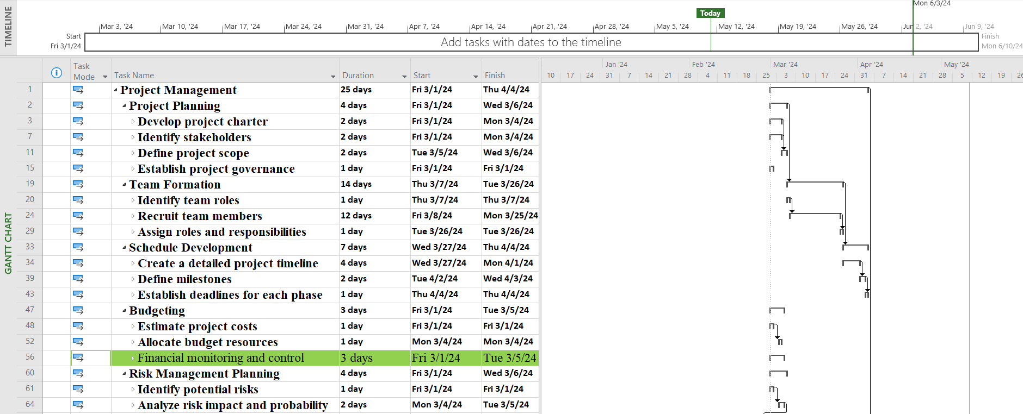
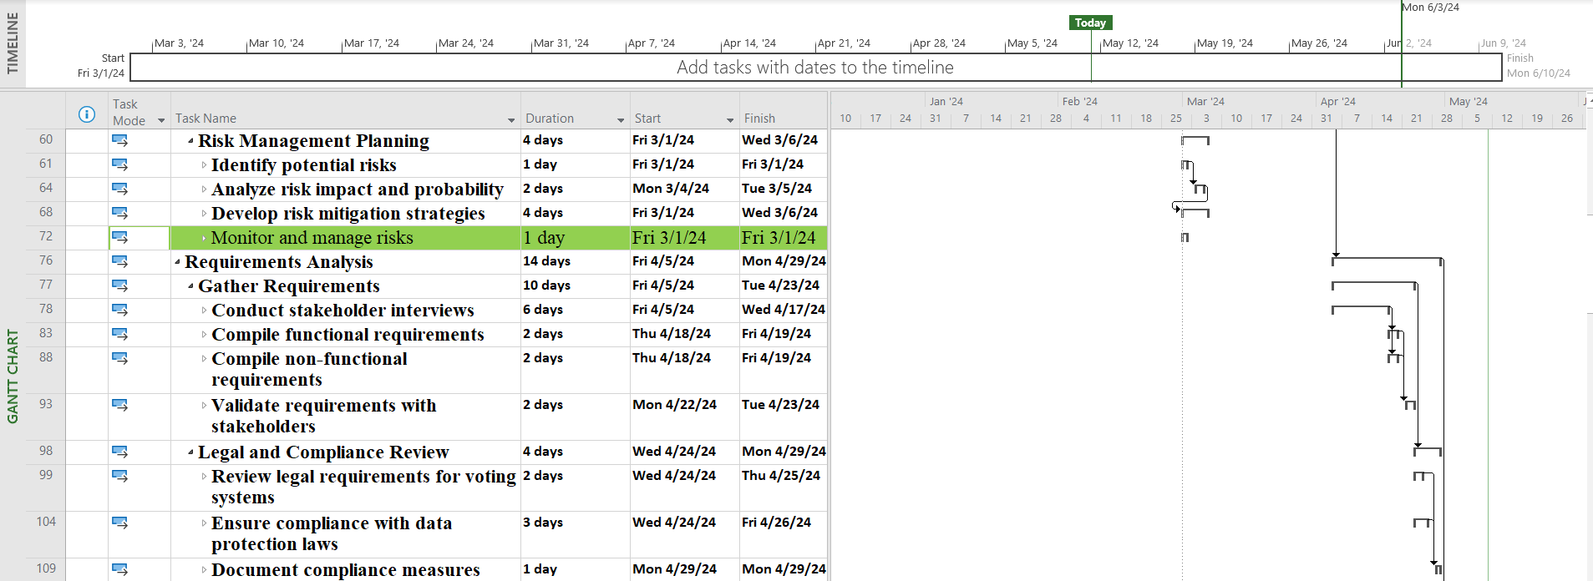
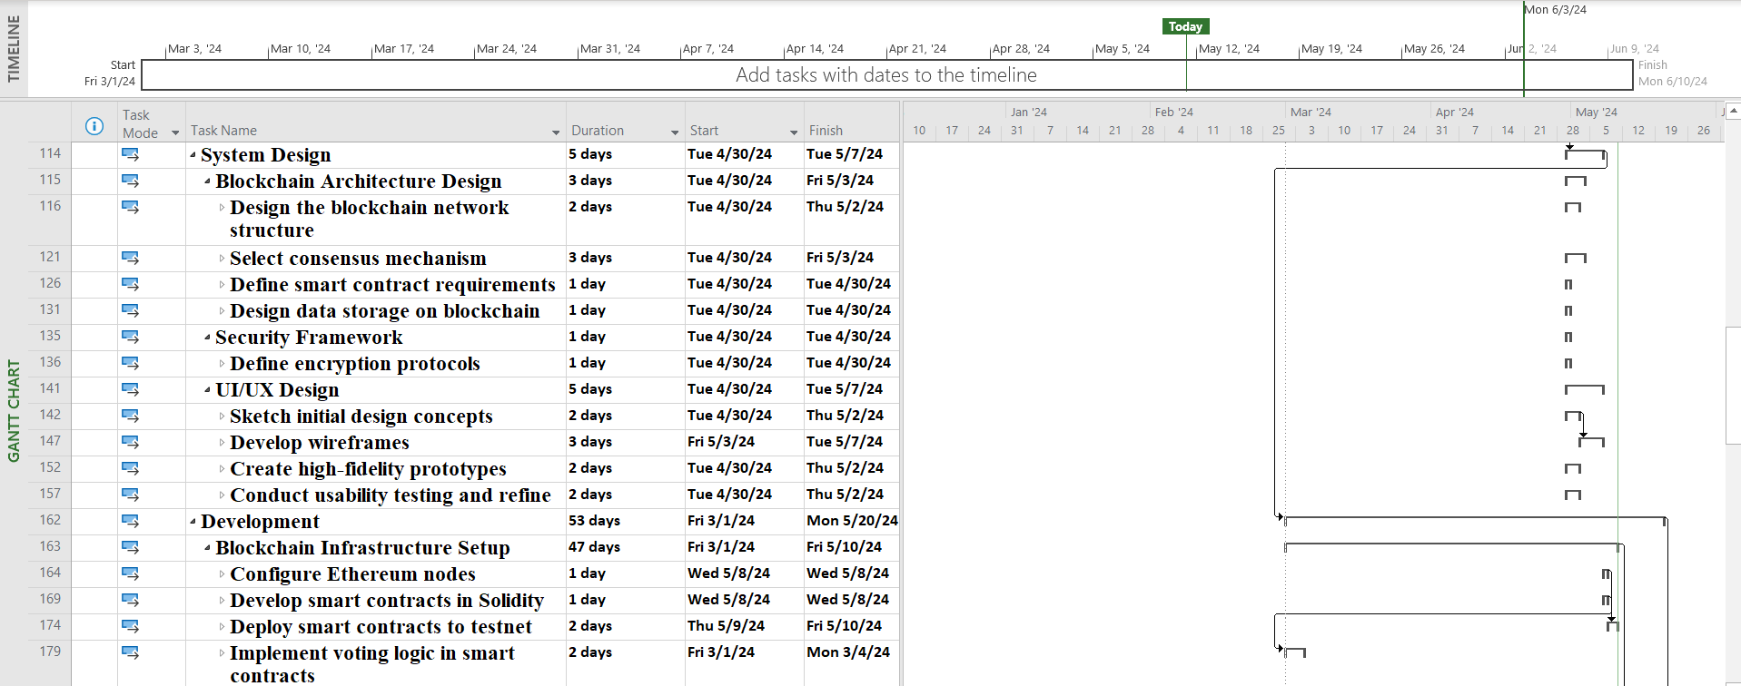
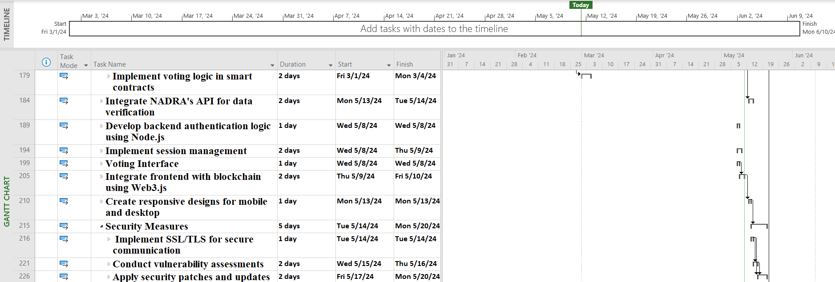
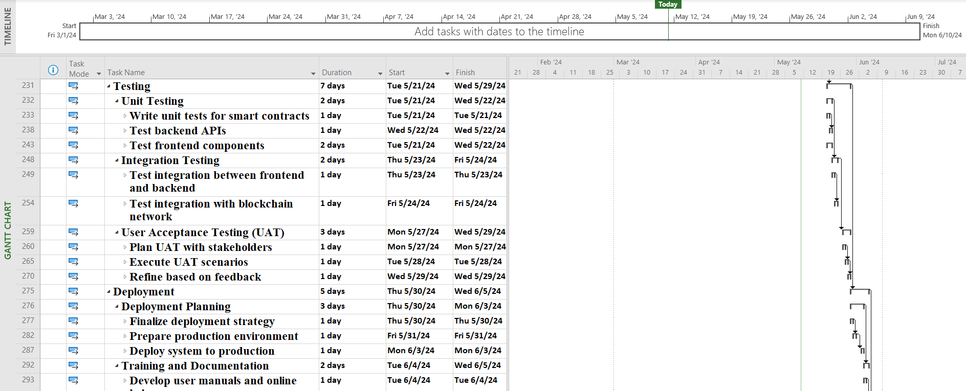
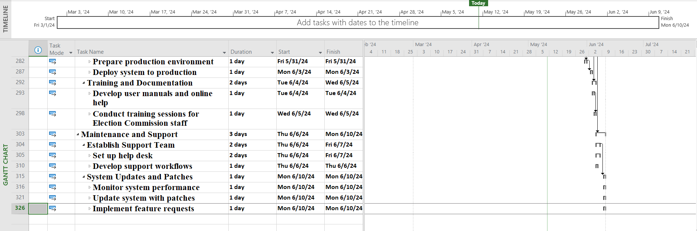

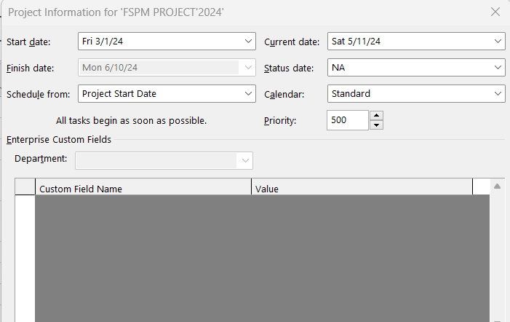
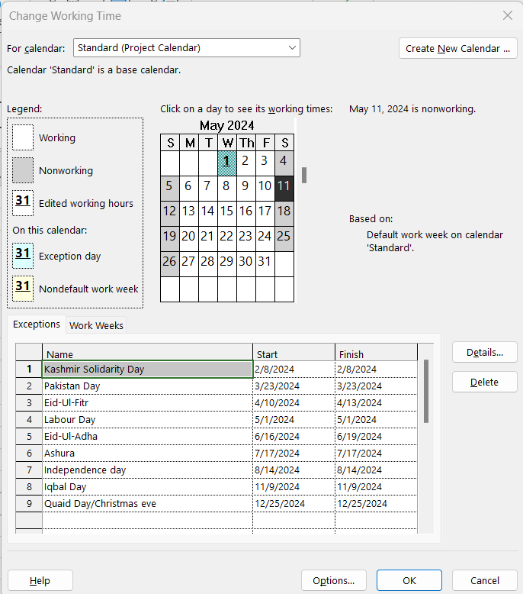

(Network Diagram)

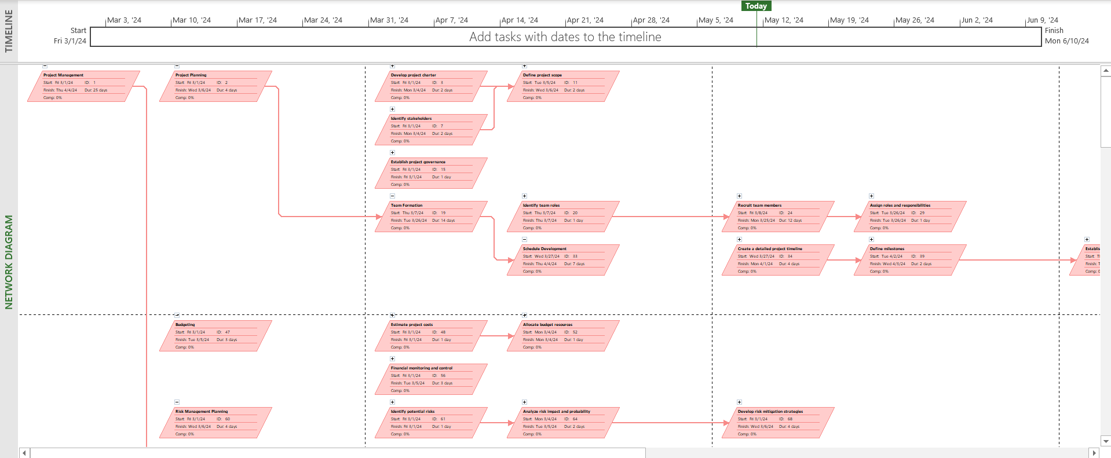
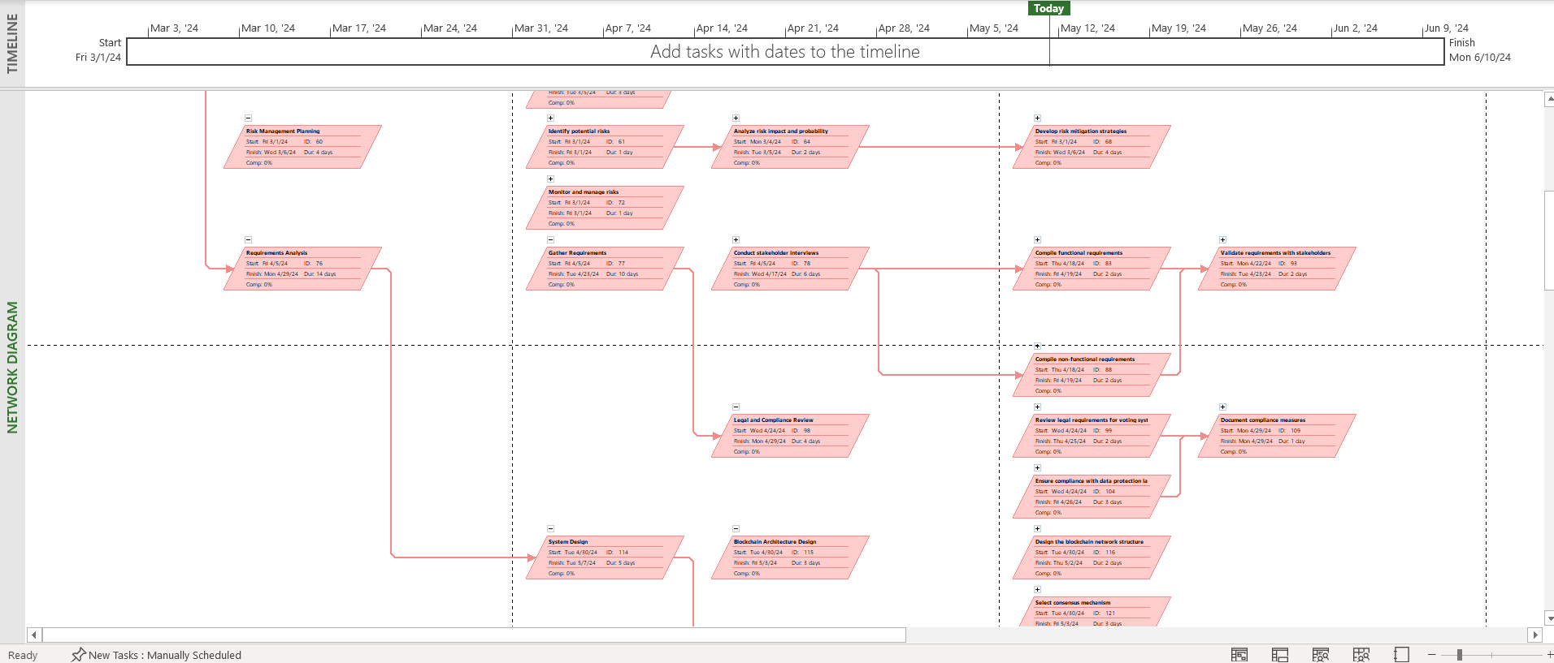
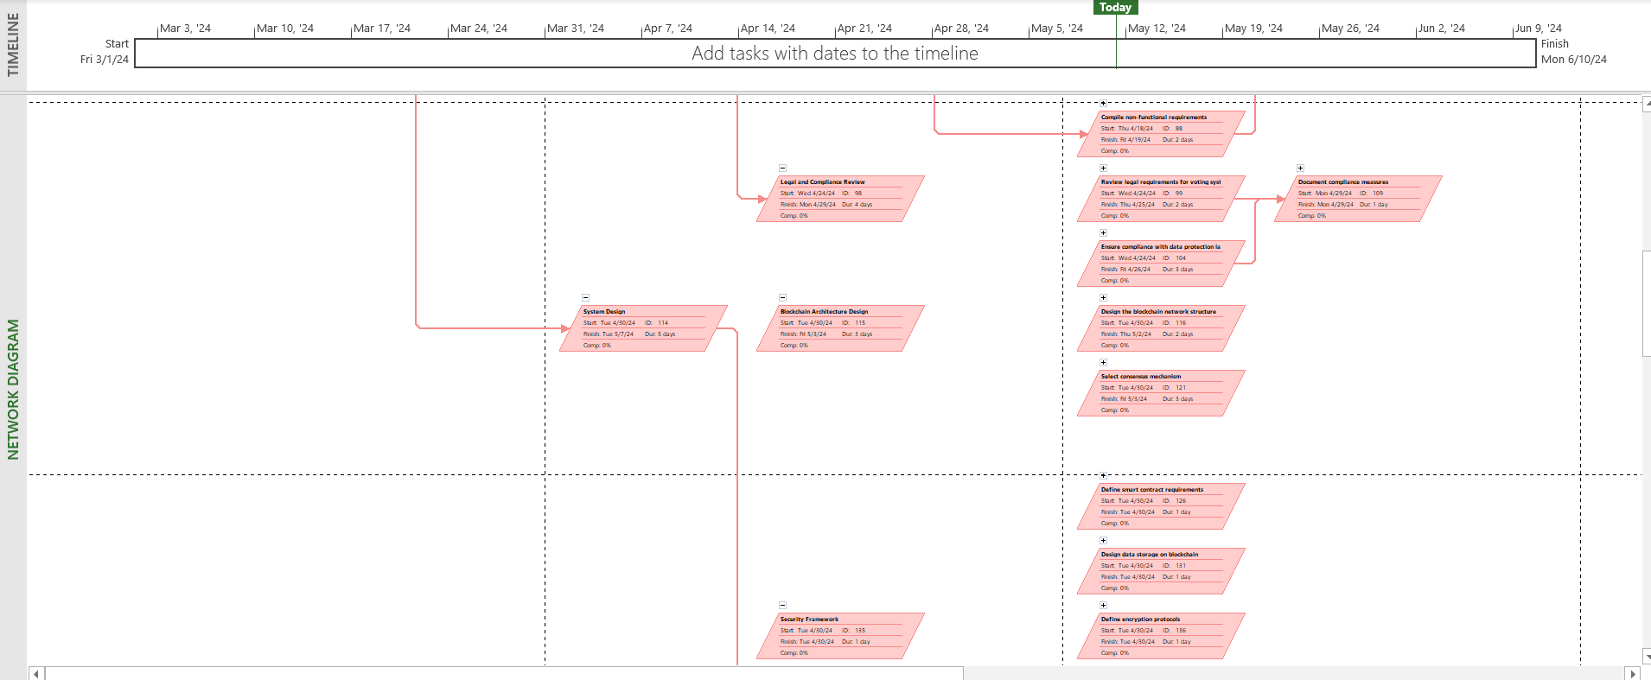
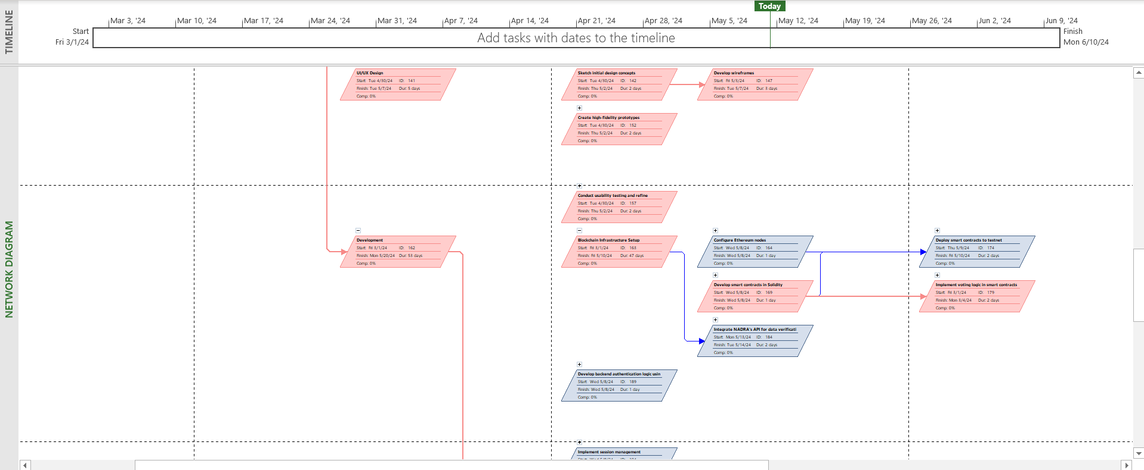
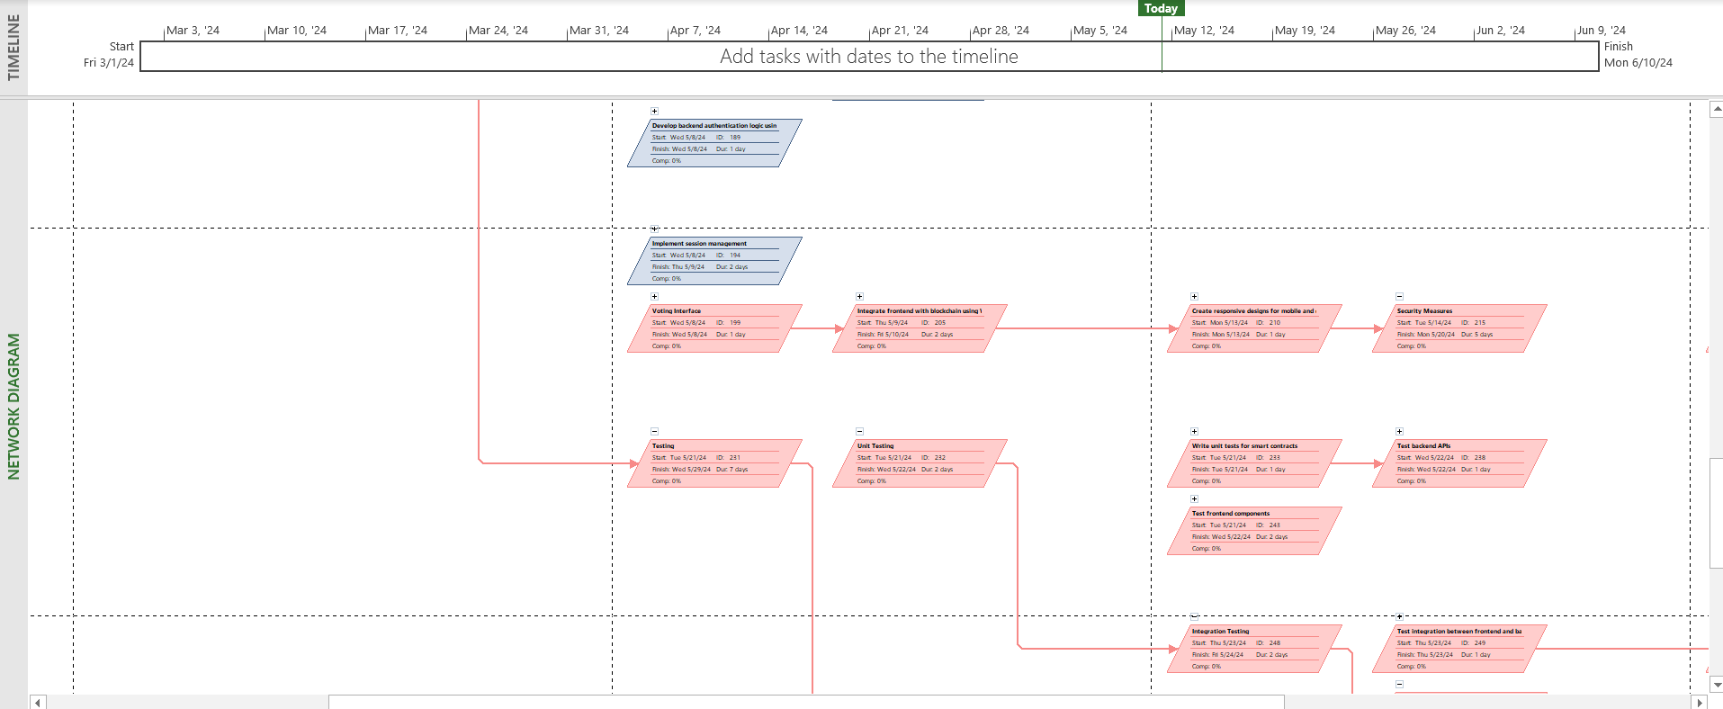
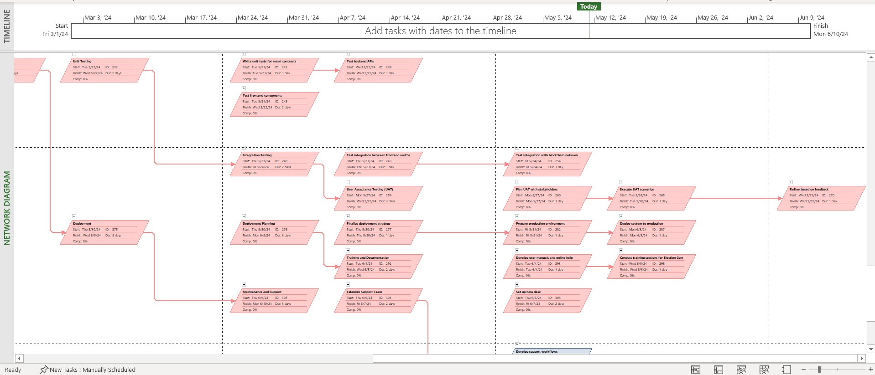
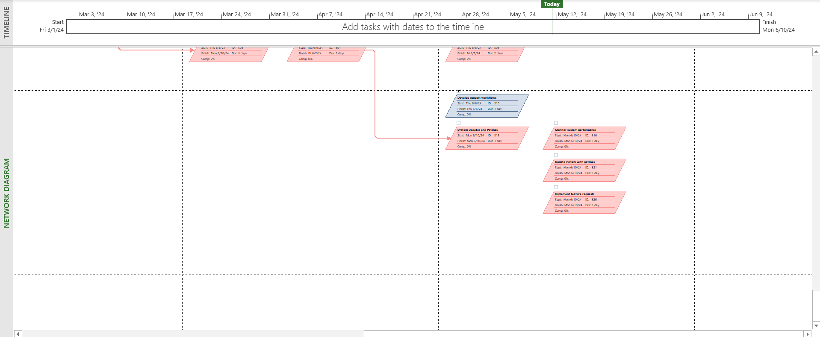

Risk Management

Task 1: Integration with NADRA's API

Risk: There is a risk that the integration with NADRA's API might face technical challenges or compatibility issues, leading to delays or failure in obtaining accurate voter authentication data.

Risk Management Strategy: To mitigate this risk, we will conduct thorough compatibility testing with NADRA's API during the development phase. Additionally, we will engage with NADRA's technical team for consultation and assistance, ensuring that any issues are promptly addressed.

Task 2: Smart Contract Development

Risk: Developing smart contracts for the voting process involves complex logic and cryptographic operations. There is a risk of errors or vulnerabilities in the smart contracts, compromising the integrity and security of the voting system.

Risk Management Strategy: To manage this risk, we will implement a rigorous code review process, involving both internal and external experts.We will also conduct extensive testing, including fuzz testing and formal verification, to identify and rectify any vulnerabilities before deployment.

Task 3: Security Vulnerabilities

Risk: The voting system is susceptible to security vulnerabilities, such as denial-of-service attacks, data breaches, or manipulation of voting records, which could undermine the integrity and trustworthiness of the electoral process.

Risk Management Strategy: We will employ a multi-layered approach to security, including encryption, access control, and intrusion detection systems. We will oversee the implementation of security measures and conduct regular security audits to identify and mitigate potential vulnerabilities. Additionally, we will collaborate with IT security consultants to stay updated on emerging threats and implement proactive measures to safeguard the system.

Task 4: User Acceptance Testing (UAT)

Risk: User acceptance testing (UAT) may reveal unforeseen usability issues or functional discrepancies that could impact user satisfaction and system adoption. Failure to address these issues promptly could lead to delays in deployment or reluctance from stakeholders to use the system.

Risk Management Strategy: We will actively involve stakeholders, including election officials and voters, in the UAT process to gather feedback and address any concerns. We will oversee the UAT sessions, ensuring that all identified issues are documented, prioritized, and resolved in a timely manner. Additionally, we will conduct multiple rounds of UAT to ensure comprehensive testing and validation of the system before deployment.

Task 5: Regulatory Compliance

Risk: Ensuring compliance with national election laws and data protection regulations poses a significant challenge, as these regulations may be subject to change or interpretation. Non-compliance could result in legal repercussions or the suspension of the voting system.

Risk Management Strategy: We will collaborate closely with legal and compliance experts to stay side by side with regulatory requirements and ensure that the voting system aligns with current laws and standards. We will cooperate with legal advisors to conduct regular reviews of the system's compliance status and implement any necessary updates or modifications. Additionally, we will maintain detailed documentation of compliance measures and provide ongoing training to election officials to ensure adherence to regulatory requirements.

Time Phased Budget

Time Phased Budget Analysis
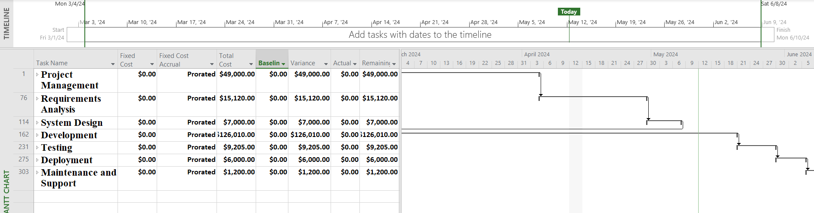
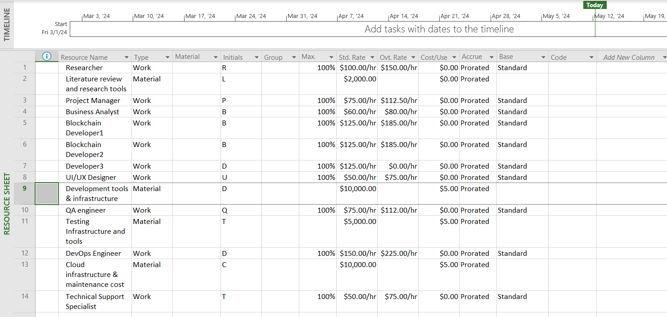

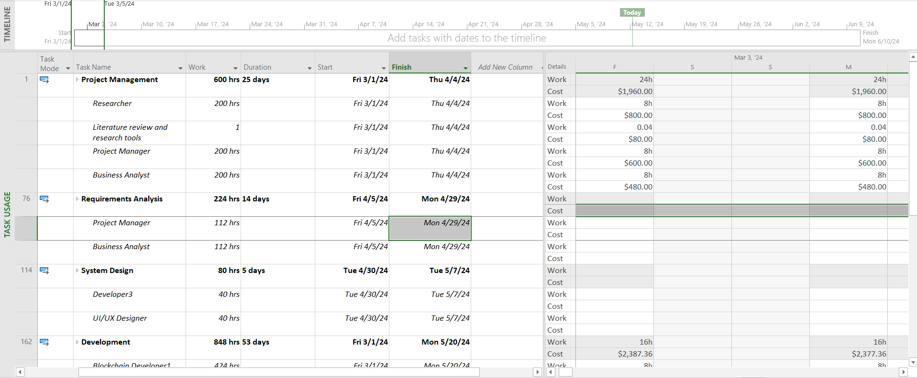
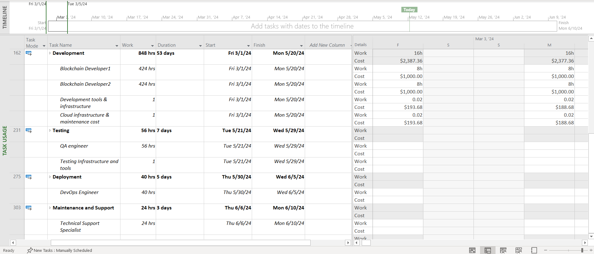

Summary
